**Angular Setup**

Definitions

npm- Node Package Manager

LTS – Long Term Support

To set up Angular in your local, we need to have npm installed in the machine.

To install the npm -> Go to the below link -> Download the compatible executable and install it.

<https://nodejs.org/en/>

**Angular setup**

**Step 1: Install the Angular CLI**

Open node js command prompt and run the below command.

npm install -g @angular/cli

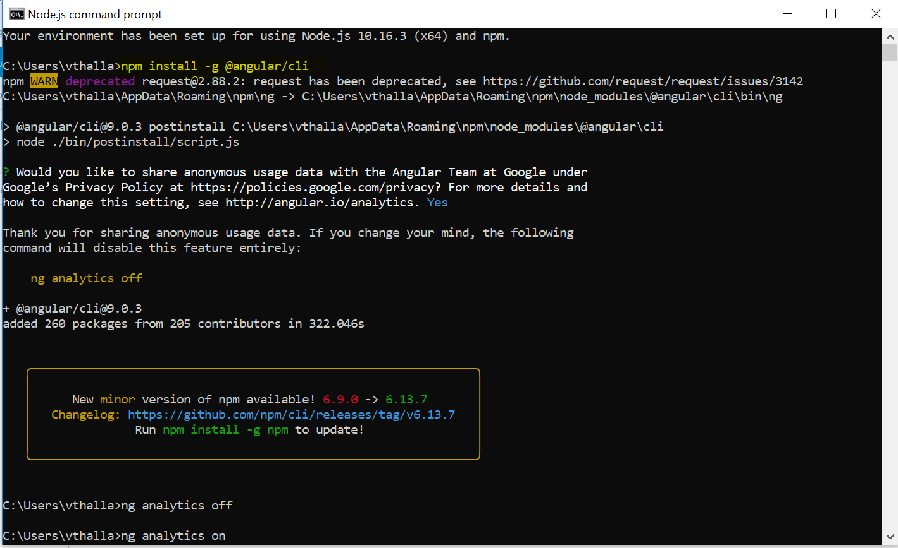

We can off the analytics by running the below command.

ng analytics off (or) ng analytics on (to on the analytics back)

## Step 2: Create a workspace and initial application

Execute/run the below command to create the angular project.

ng new my-dashboard-app

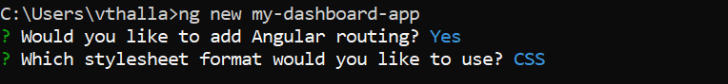

After successful completion of the setup, we will see a screen like shown below.

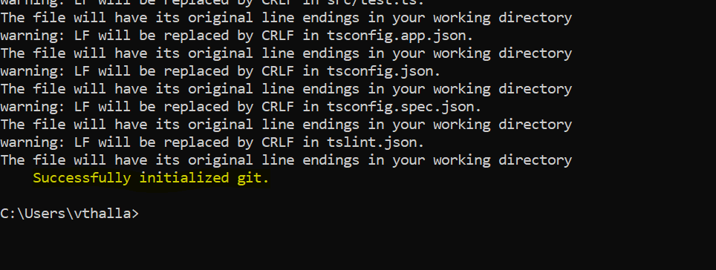

Initial project structure would get created in the directory that we selected.

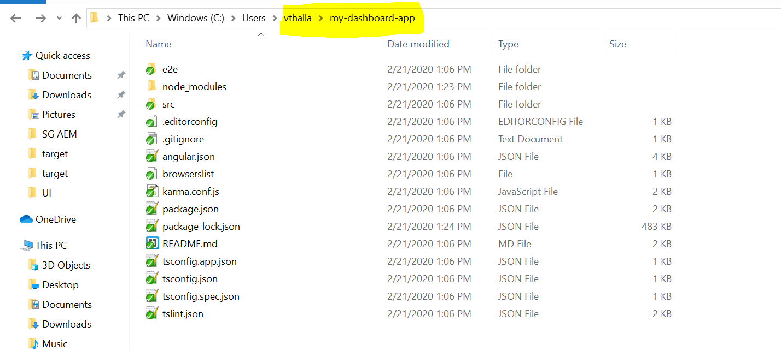

## Step 3: Run the application

1. Go to the workspace folder (my-app).
2. Launch the server by using the CLI command ng serve, with the --open option.

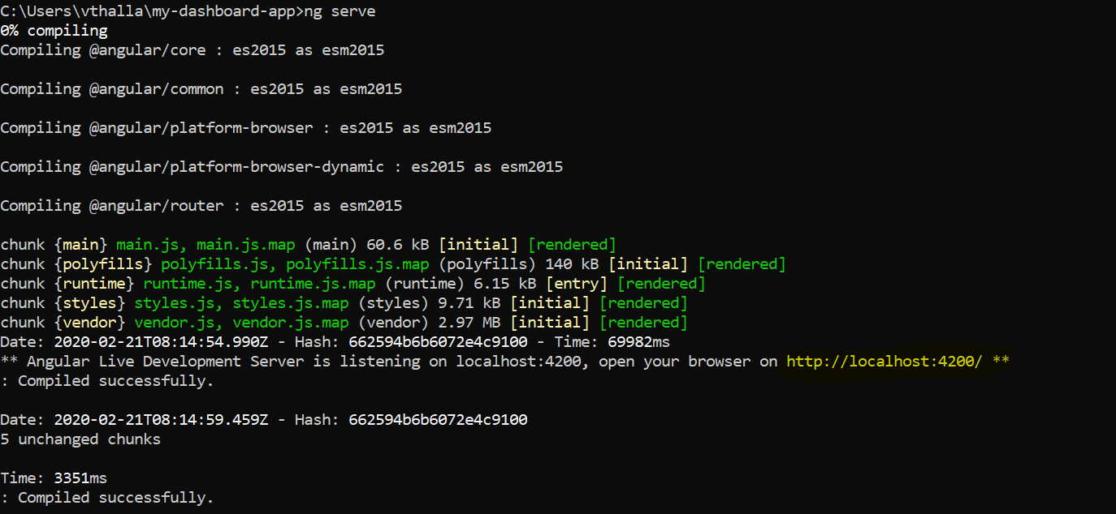

It will show you the port number on which the angular application is running (highlighted with yellow background in the screenshot).

Open the link in the browser, we will see the screen like below.

